**How to take part in virtual Council meetings**

1. Open your Microsoft Outlook (emails).
2. Click into your calendar, and then into the meeting invitation for the meeting that you would like to join.
3. At the bottom of the meeting invitation, there should be an option to ‘Join Microsoft Teams Meeting’. By clicking on this, you will be redirected to the meeting in the desktop application. Please ensure that you have clicked into the meeting 10-15 minutes before it is due to start to correct any technical issues and ensure a punctual meeting start time.

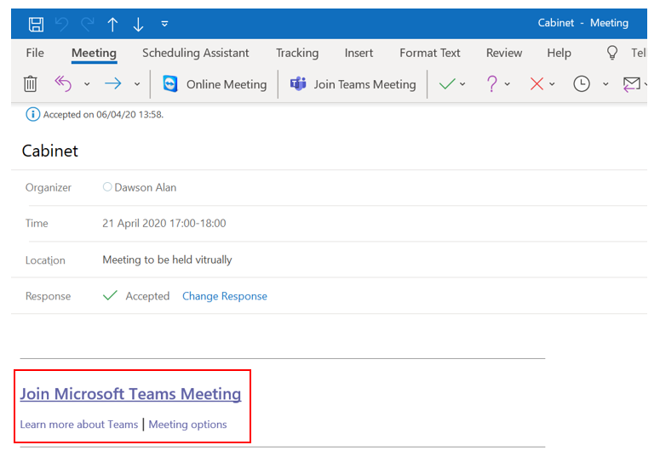

1. When you have clicked into the ‘Join Microsoft Teams Meeting’ option in the meeting invite, you should be presented with the following screen. Please ensure that you join the meeting with your camera switched off and your microphone muted, by clicking on the first (video) and third (microphone) toggles below. After this, please click ‘Join now’ to join the meeting.

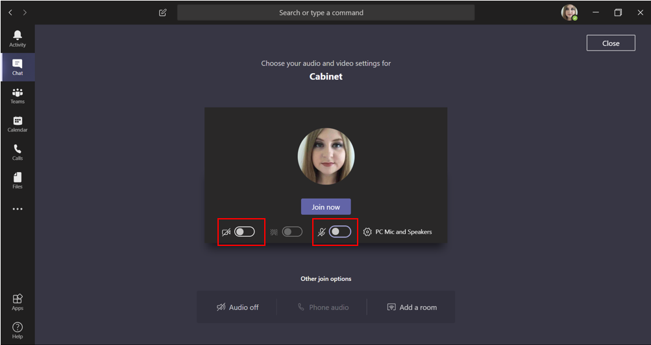

**During the meeting:**

Please ensure that you adhere to the points below.

For settings and options relating to the following, hover your computer mouse over the centre of the screen when in the Virtual Meeting and the ribbon should appear. If you are using an iPad, please click the centre of your screen for these options.

1. **Please keep your microphone muted when you are not speaking-** even just breathing or writing notes can have a detrimental impact on the audio of the meeting (and imagine this x the number of participants in the meeting!) To mute and unmute your microphone, please click the second button on the ribbon:

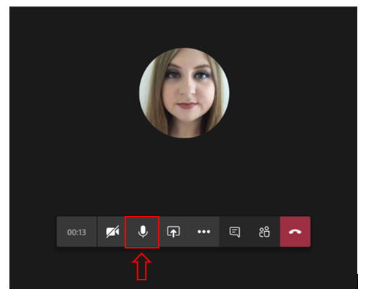

1. **You can blur your background.** This blurs out whatever is behind you, making you more prominent to viewers, helping them to stay focused and protecting your privacy.To do this, click on the fourth button in (the three ‘dots’) for more settings, and then click on ‘show background effects’, where you will then have the option to blur your background. You may wish to do this before you join the meeting.

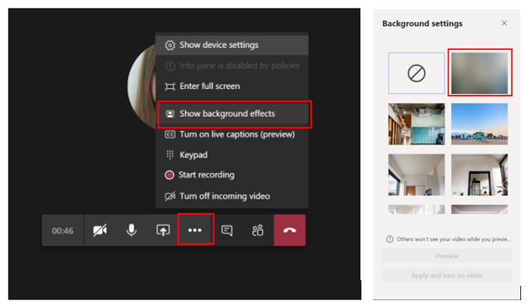

1. **Please use the chat function to indicate that you wish to speak.** Click on the fifth button into the ribbon to open the chat function. Once you are into the chat function, you will be able to type your own messages and view those of others. If you wish to speak, simply type ‘speak’ into the chat box and the Chair of the meeting will respond to you at the next appropriate point in the meeting. Remember that all who are on the call will be able to read what is in ‘Chat’ including members of the public if they have signed up in advance.

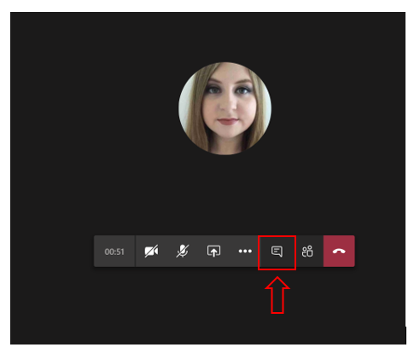

1. **You can use the chat function to send a message to one person on the call.** To do this, hover your cursor over the image/logo of the person you wish to contact and the message prompt will come up. You can then write your message and click the arrow to send.

