**How to take part in virtual Council meetings on iPads**

1. Open your Microsoft Outlook
2. Click into your calendar, then make sure the correct day or week is selected, then touch the meeting invitation for the meeting that you would like to join.

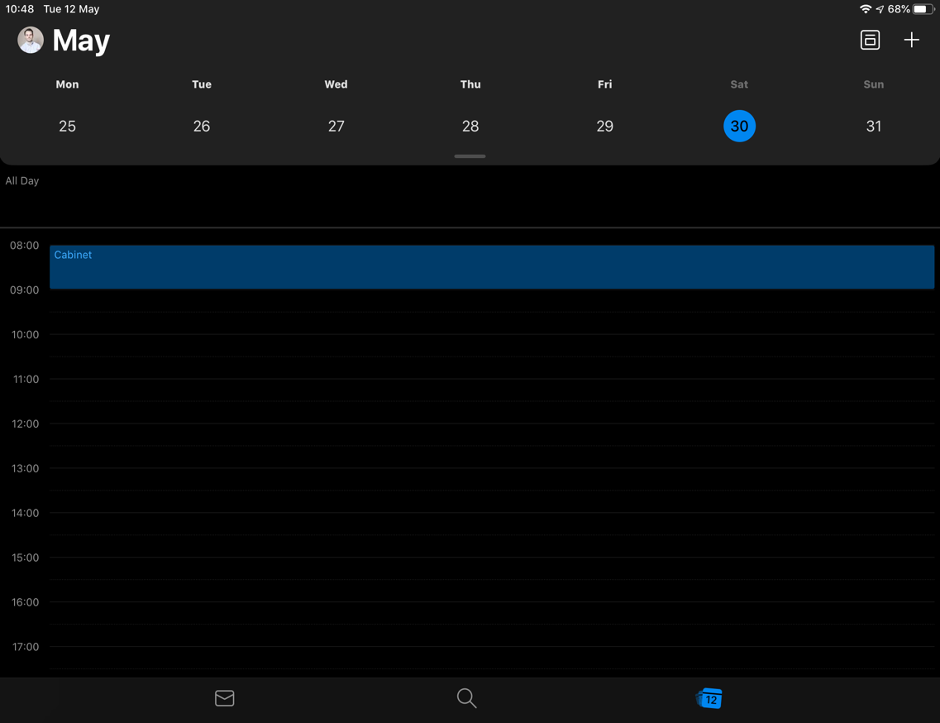

1. In the meeting invitation, there should be a button to ‘Join’ next to the text “Teams Meeting”. By touching on this, you will be redirected to the Teams application. Please ensure that you have clicked into the meeting 10-15 minutes before it is due to start to correct any technical issues and ensure a punctual meeting start time.

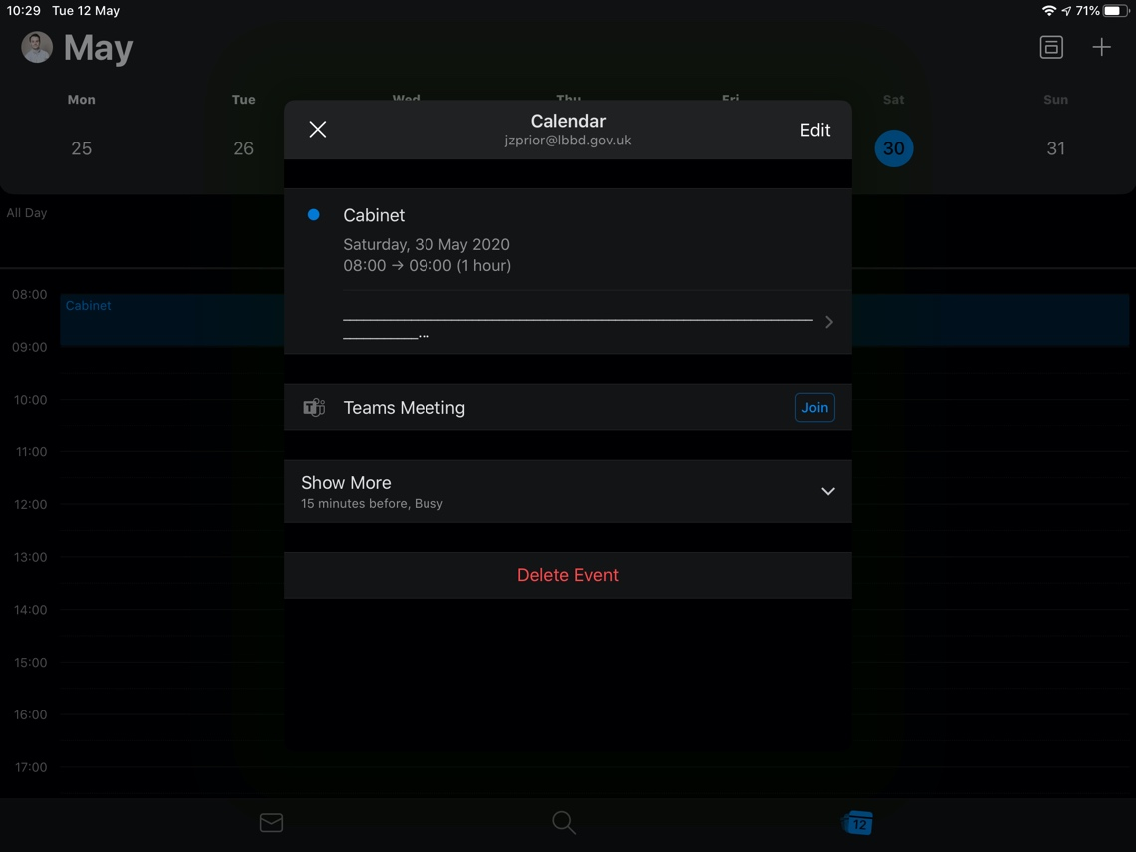

1. When you have touched the ‘Join’ option in the meeting invite, you should be presented with the following screen. Please ensure that you join the meeting with your camera switched off and your microphone muted, by clicking on the first (video) and second (microphone) toggles below. After this, please touch ‘Join now’ to join the meeting

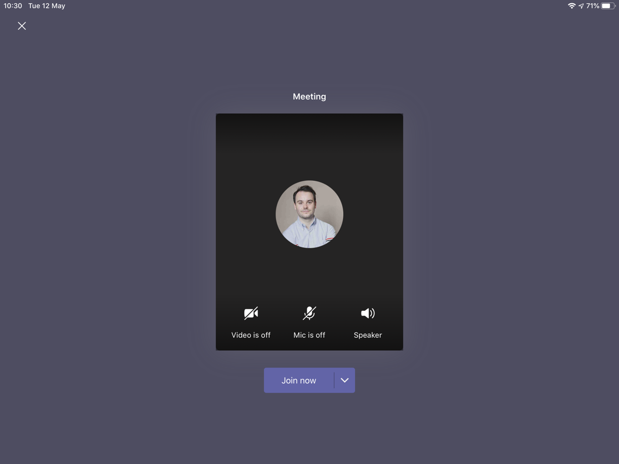

**During the meeting:**

Please ensure that you adhere to the points below. You can **click the centre of your screen** for these options.

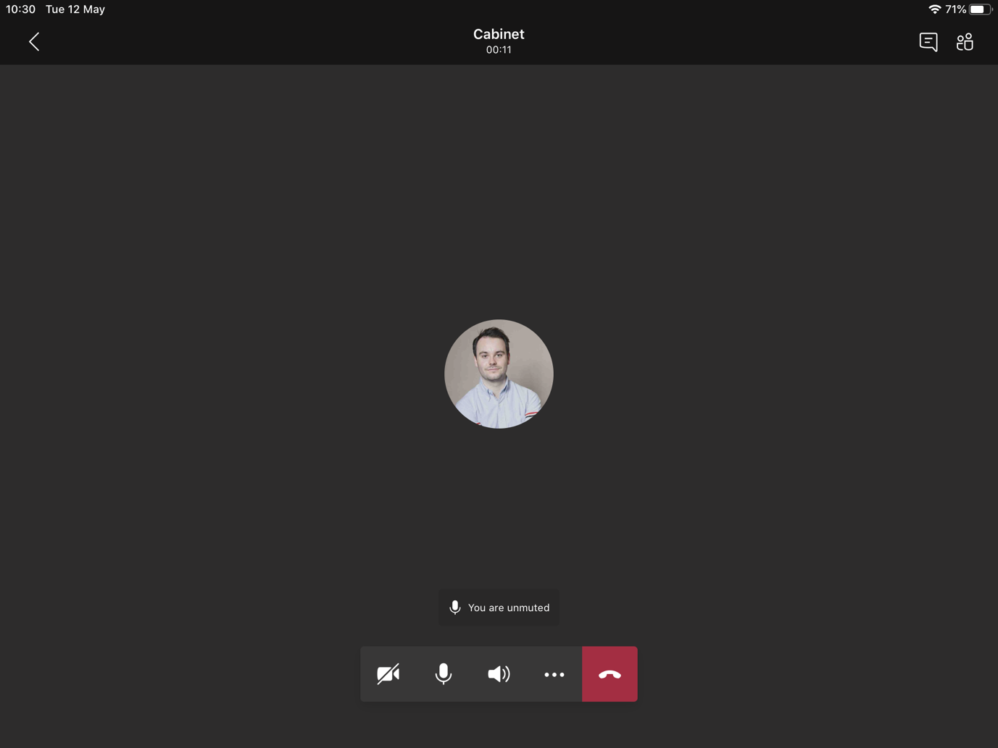

1. **Please keep your microphone muted when you are not speaking-** even just breathing or writing notes can have a detrimental impact on the audio of the meeting (and imagine this x the number of participants in the meeting!) To mute and unmute your microphone, please click the second button on the ribbon:
2. **You can turn your video on and off,** blurring backgrounds is not currently available on iPads
3. **Please use the chat function to indicate that you wish to speak.** Touch the chat button in the top right of the screen to open the chat. Once you are into the chat function, you will be able to type your own messages and view those of others. If you wish to speak, simply type ‘speak?’ into the chat box and the Chair of the meeting will respond to you at the next appropriate point in the meeting. Remember that all who are on the call will be able to read what is in ‘Chat’ including members of the public if they have signed up in advance. To leave chat please touch the back arrow

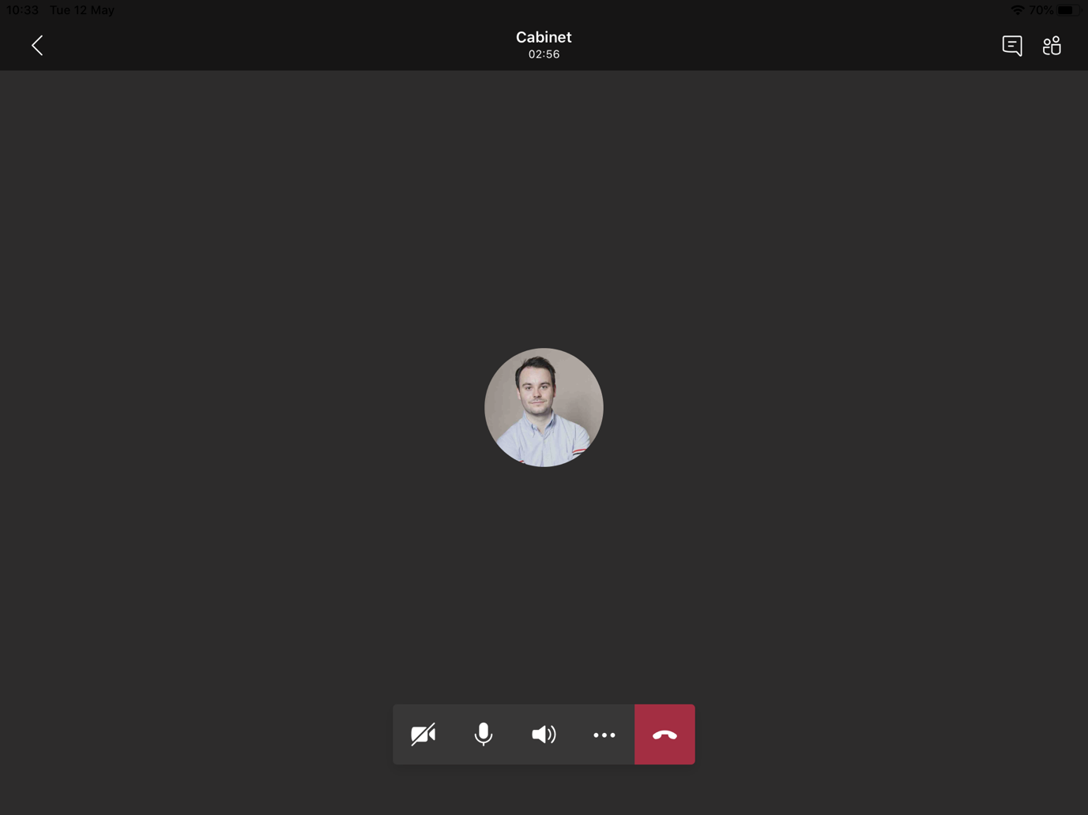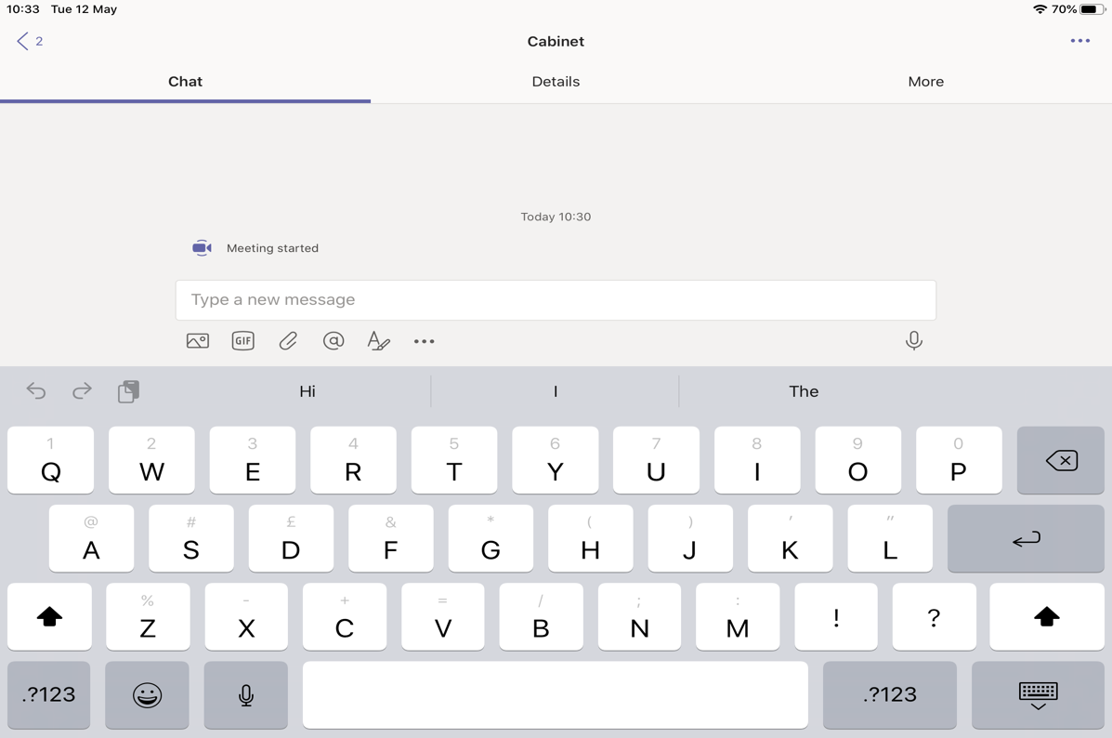

1. **You can use the chat function to send a message to one person on the call.** To do this, touch the image/logo of the person you wish to contact and then touch the view profile button in the prompt that comes up.

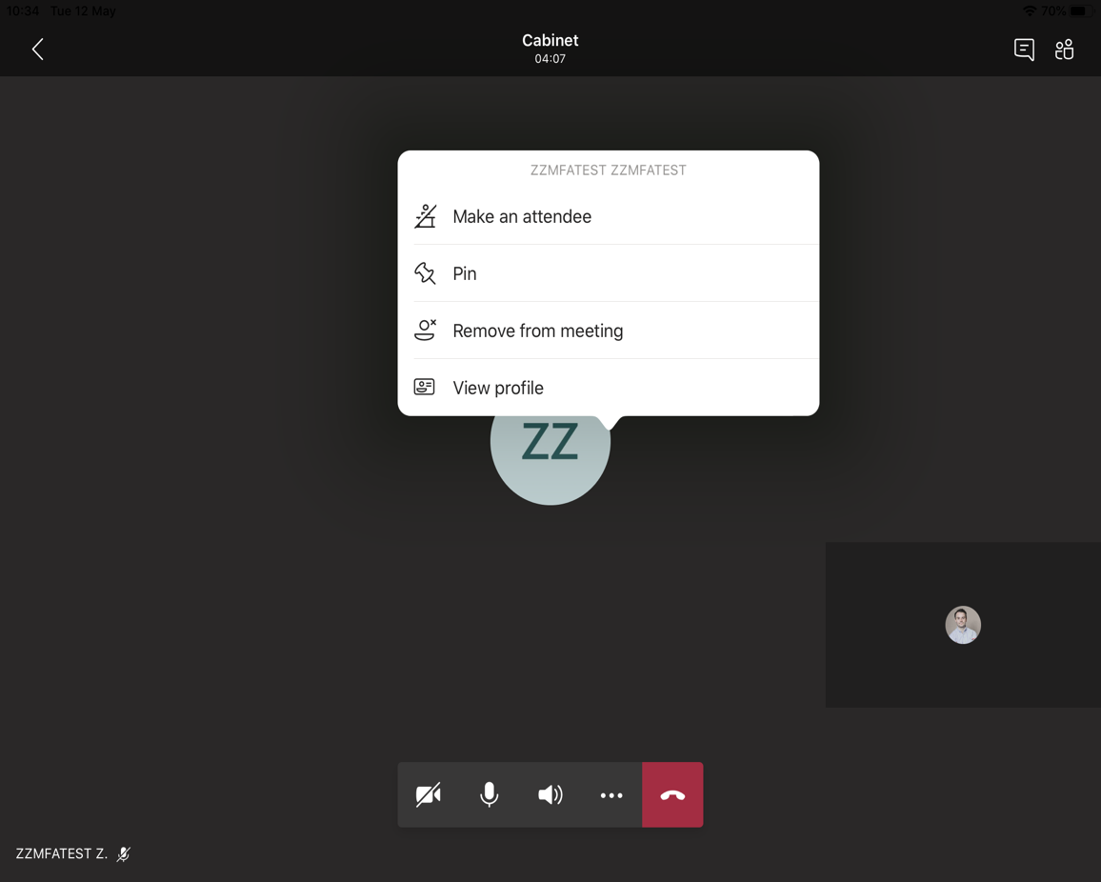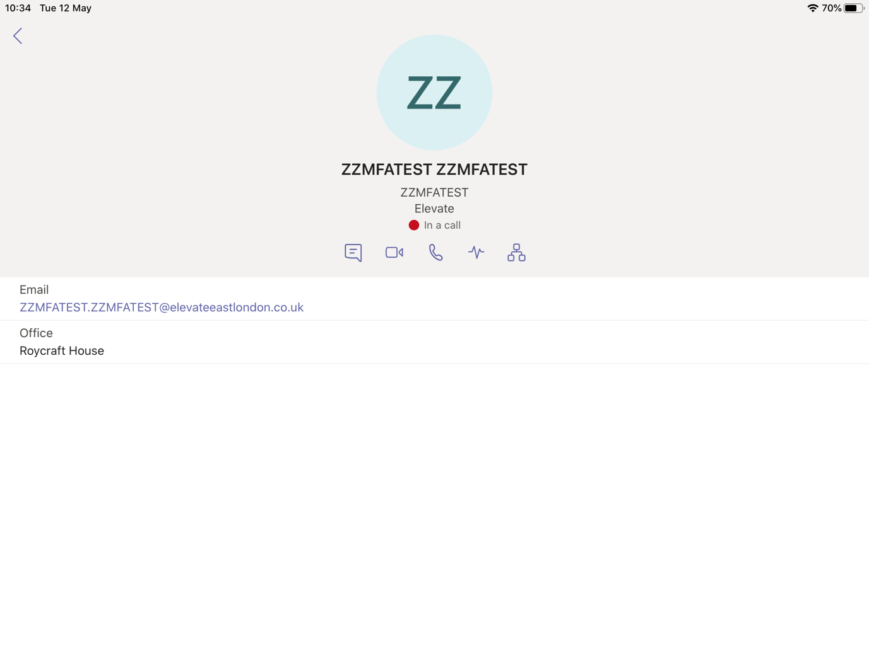

1. You can then touch the chat button to chat to them
2. You will then be taken into the chat window below. Once you have finished chatting with the user touch the dark blue box to maximise the meeting again.

