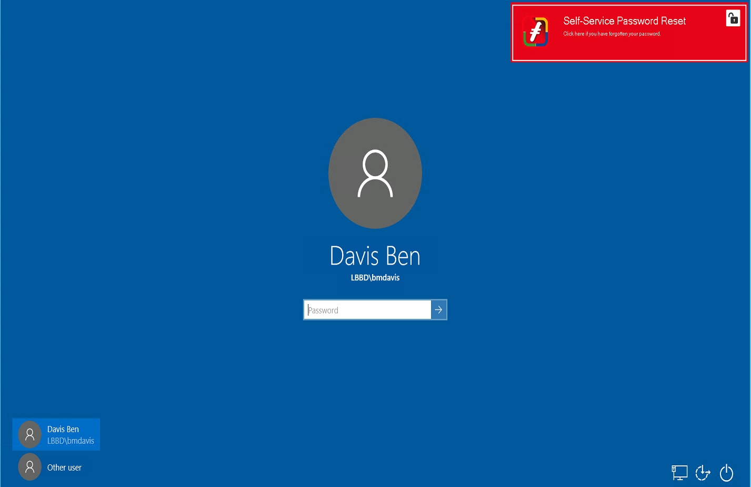**Your Laptop**

You have been issued a Dell laptop running Windows 10. This is the standard laptop that all LBBD staff use, If you have any questions please contact the service desk by email at [itsupport@elevateeastlondon.co.uk](mailto:itsupport@elevateeastlondon.co.uk) or by phone on 02082272013.

Please turn your Laptop on for at least a few hours every month, this will allow it to download all of the newest security and software updates.

**Passwords**

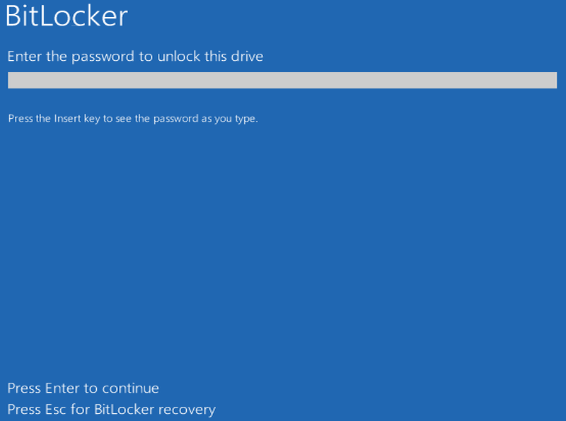To access your laptop you’ll need to use two different passwords. When you see the screen below you need to enter your Bitlocker password.

After this screen you’ll be prompted to enter your user name and network password. Please wait 10 seconds before you type in your password, this will ensure your laptop is connected to our network before you log in.

If you forget either of these passwords please call the service desk on 02082272013.

**Connecting to an external Wi-Fi network**

Your Laptop is set up to automatically connect to the LBBD Wi-Fi network, however if you’re working from home, a coffee shop or anywhere else that offers Wi-Fi you’ll need to follow the steps below.

1. Click the Wi-Fi button in the bottom hand corner

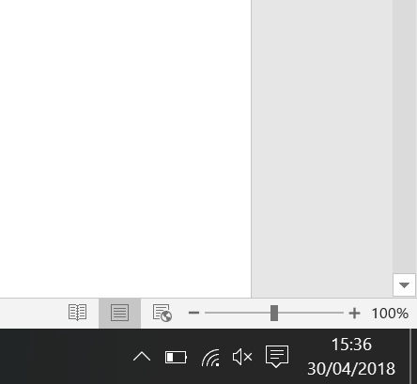

1. Select the network you’d like to connect to E.g. (AGI-BAD-WLAN) and click connect.

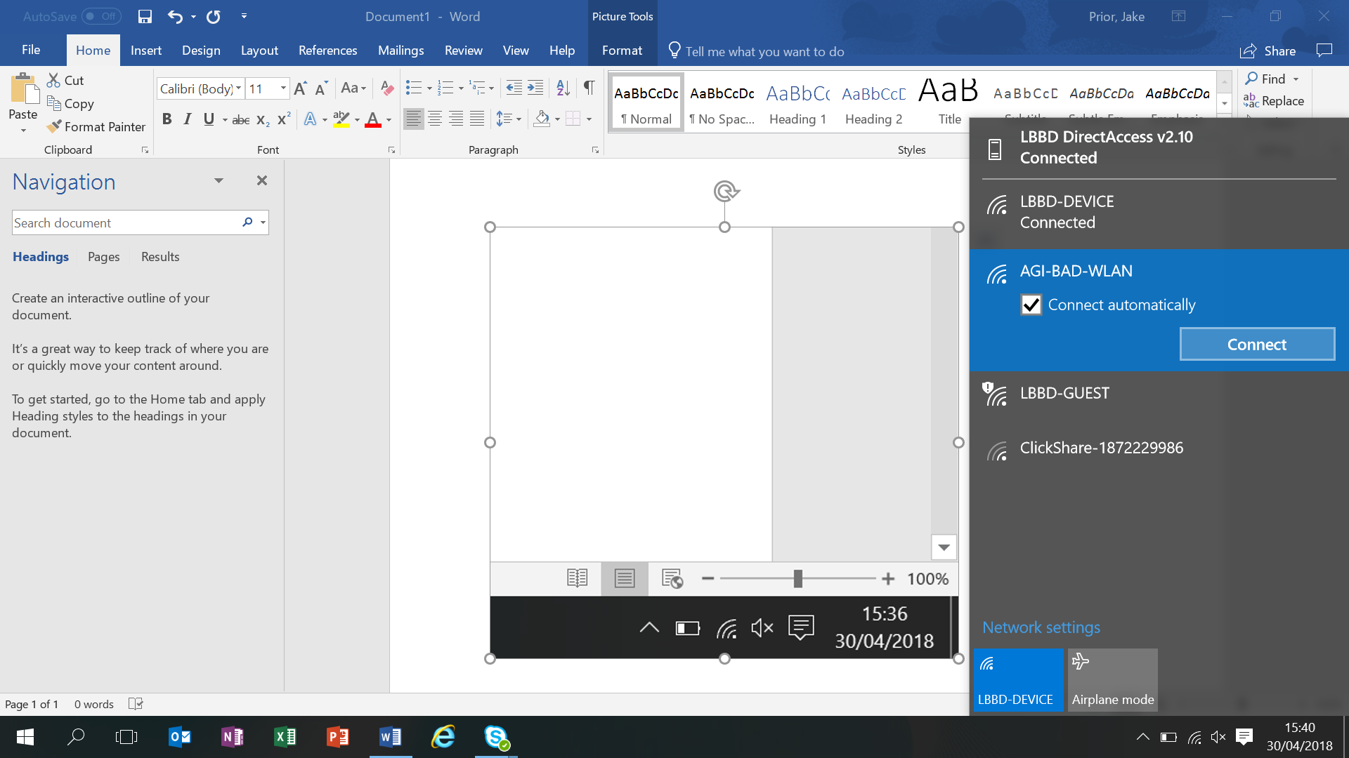

1. Type in the Wi-Fi password if needed and then click next.

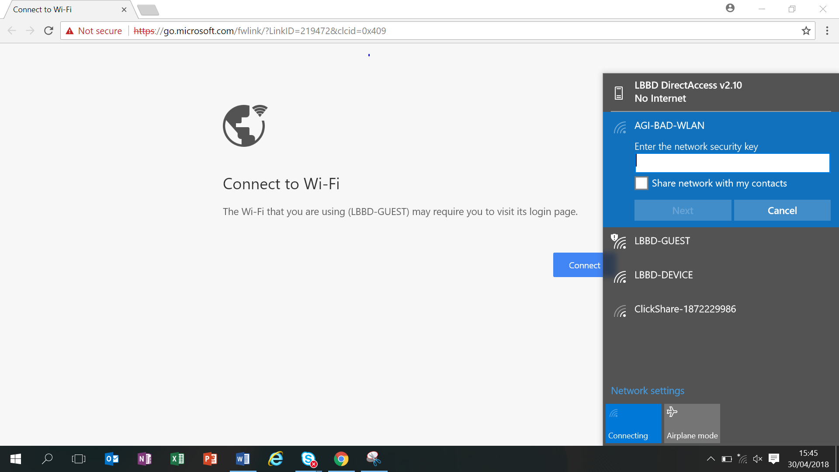

**Accessing Oracle**

To access your Payslip or to make expense claims you’ll need to navigate to Oracle. You will only be able to access Oracle on your laptop and not your iPad. If you forget your Oracle password you’ll need to click on Login Assistance after following step 4.

Click on Login Assistance after following step 4 below.

1. 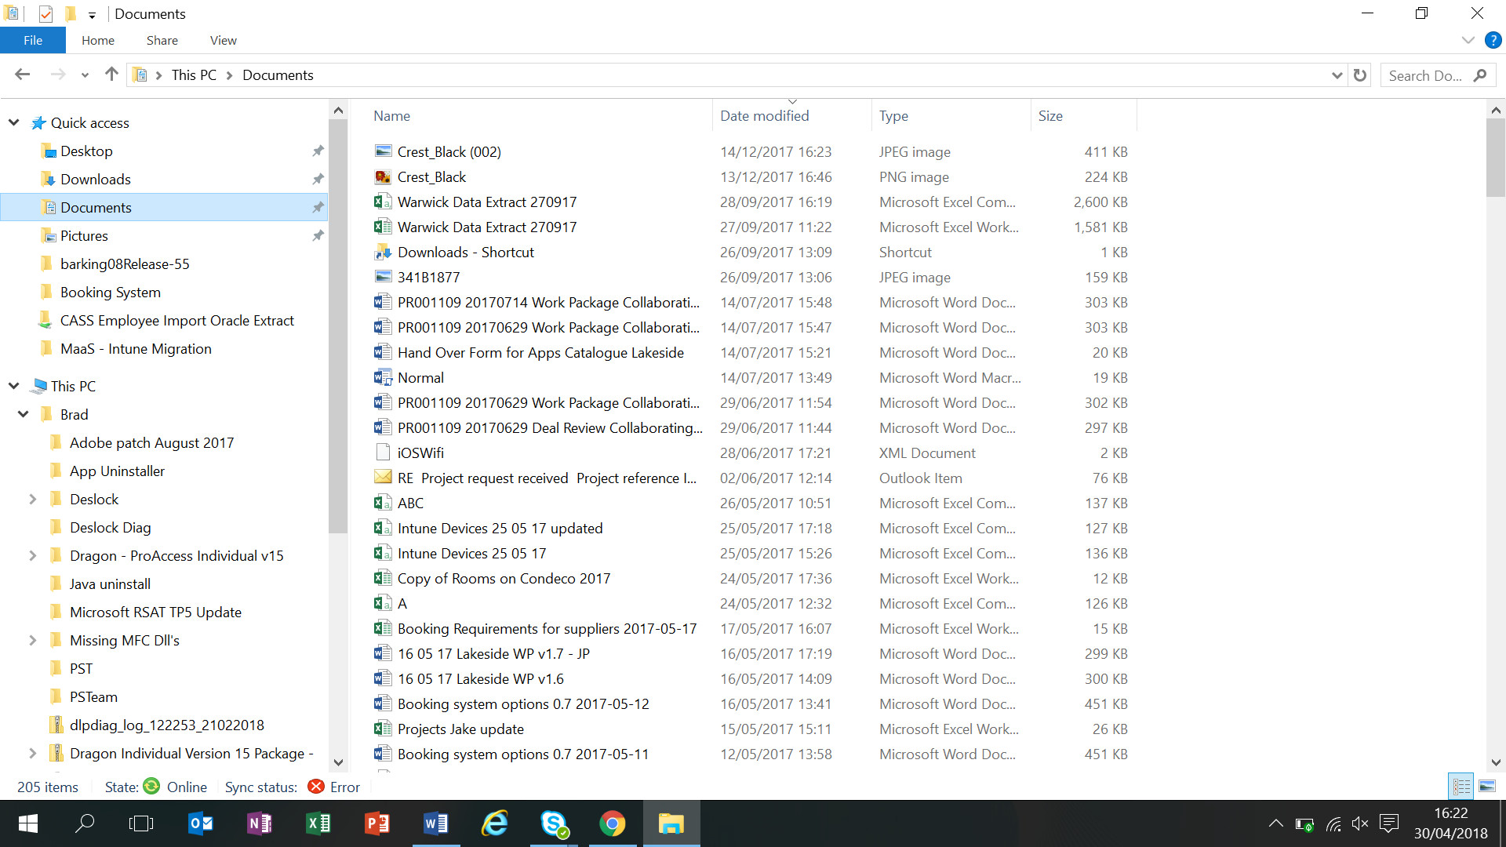Click Internet Explorer
2. When Internet Explorer loads it will show the LBBD intranet page on the left hand side. Please click 1 Oracle

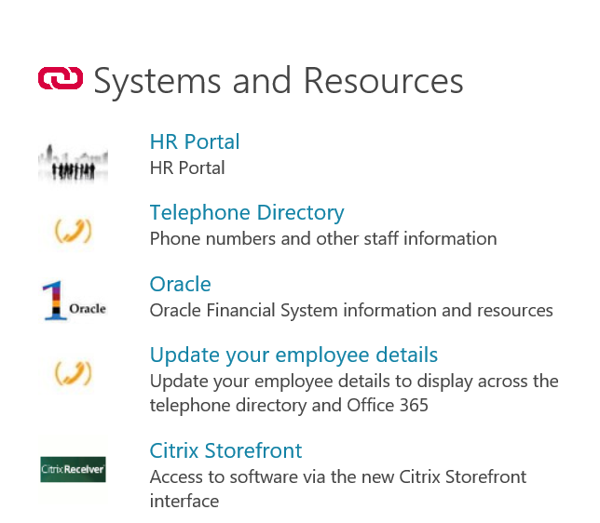

1. 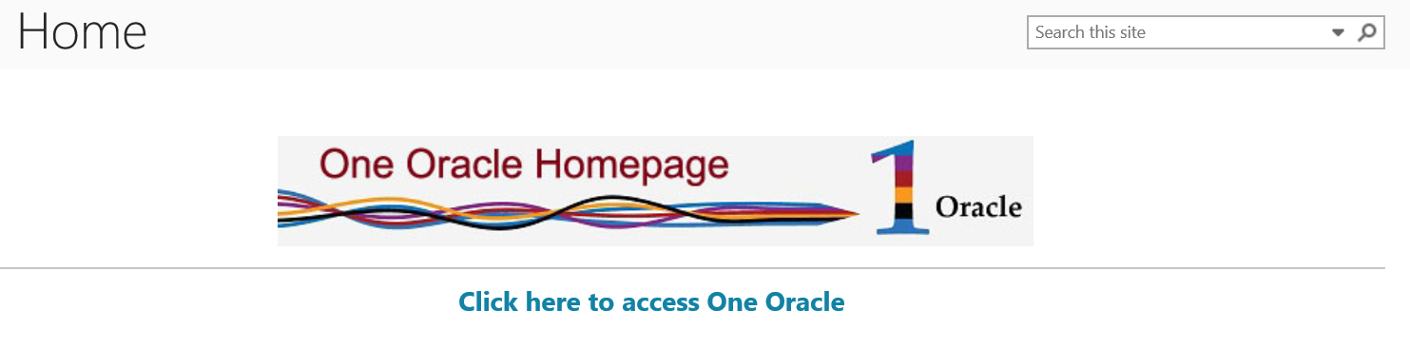A popup will then take you to the page below, please click “Click here to access One Oracle”
2. 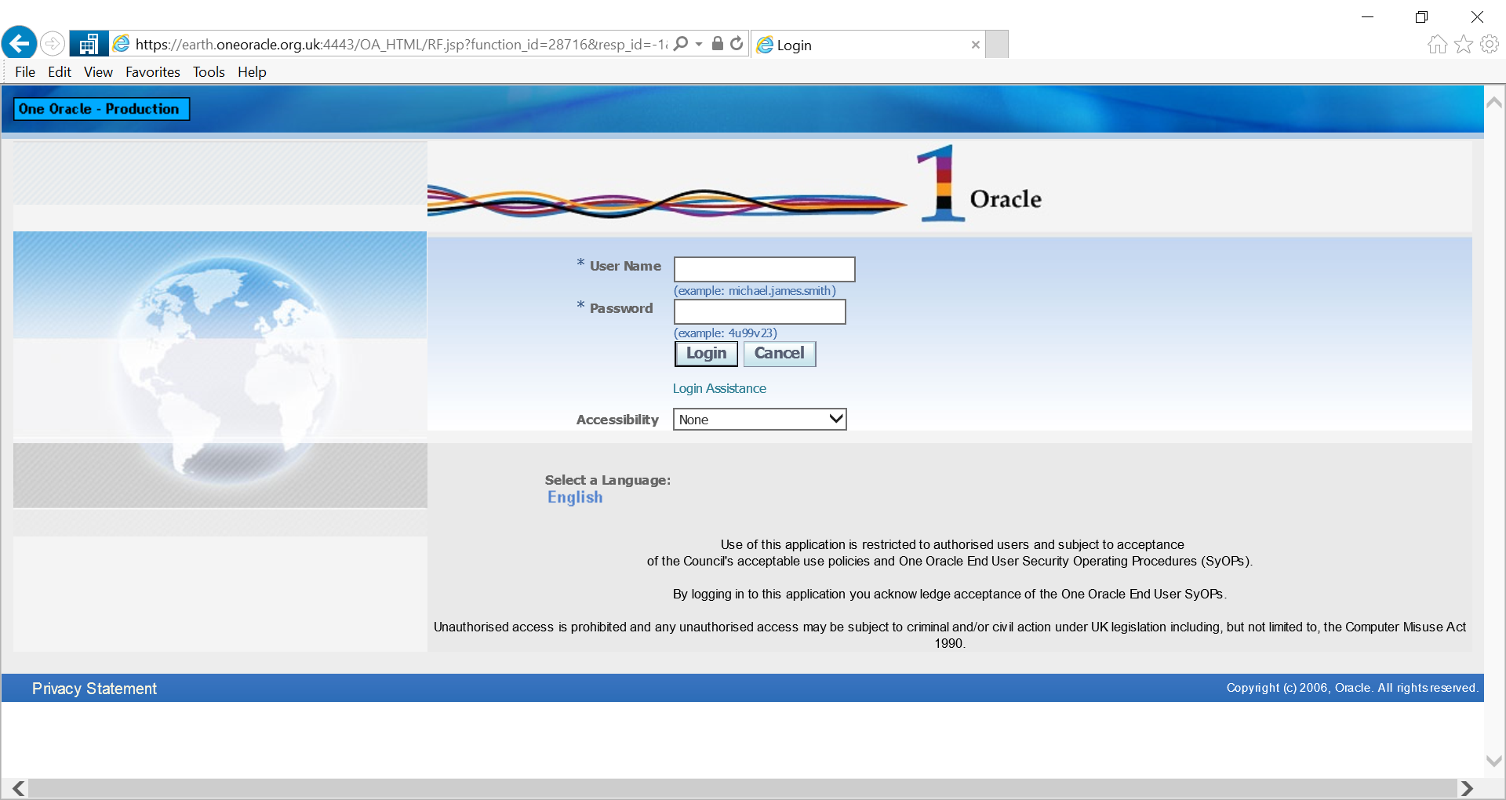Oracle will then open and ask you for your login information.