**Your iPad**

You have been issued with an iPad that is specifically set up for LBBD Members. This iPad includes customisations and applications specific to Members.

If you have any questions please contact the service desk by email at [itsupport@elevateeastlondon.co.uk](mailto:itsupport@elevateeastlondon.co.uk) or by phone on 02082272013.

**Changing Your iPad Passcode**

To access your iPad, you’ll need to use a 6-digit pin. This is different to your network password or you Bitlocker pin.

1. 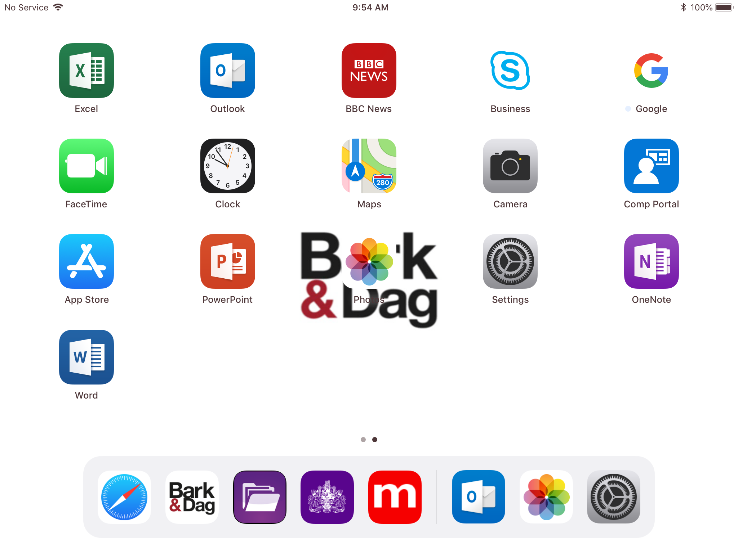Touch the settings applications on your home screen
2. 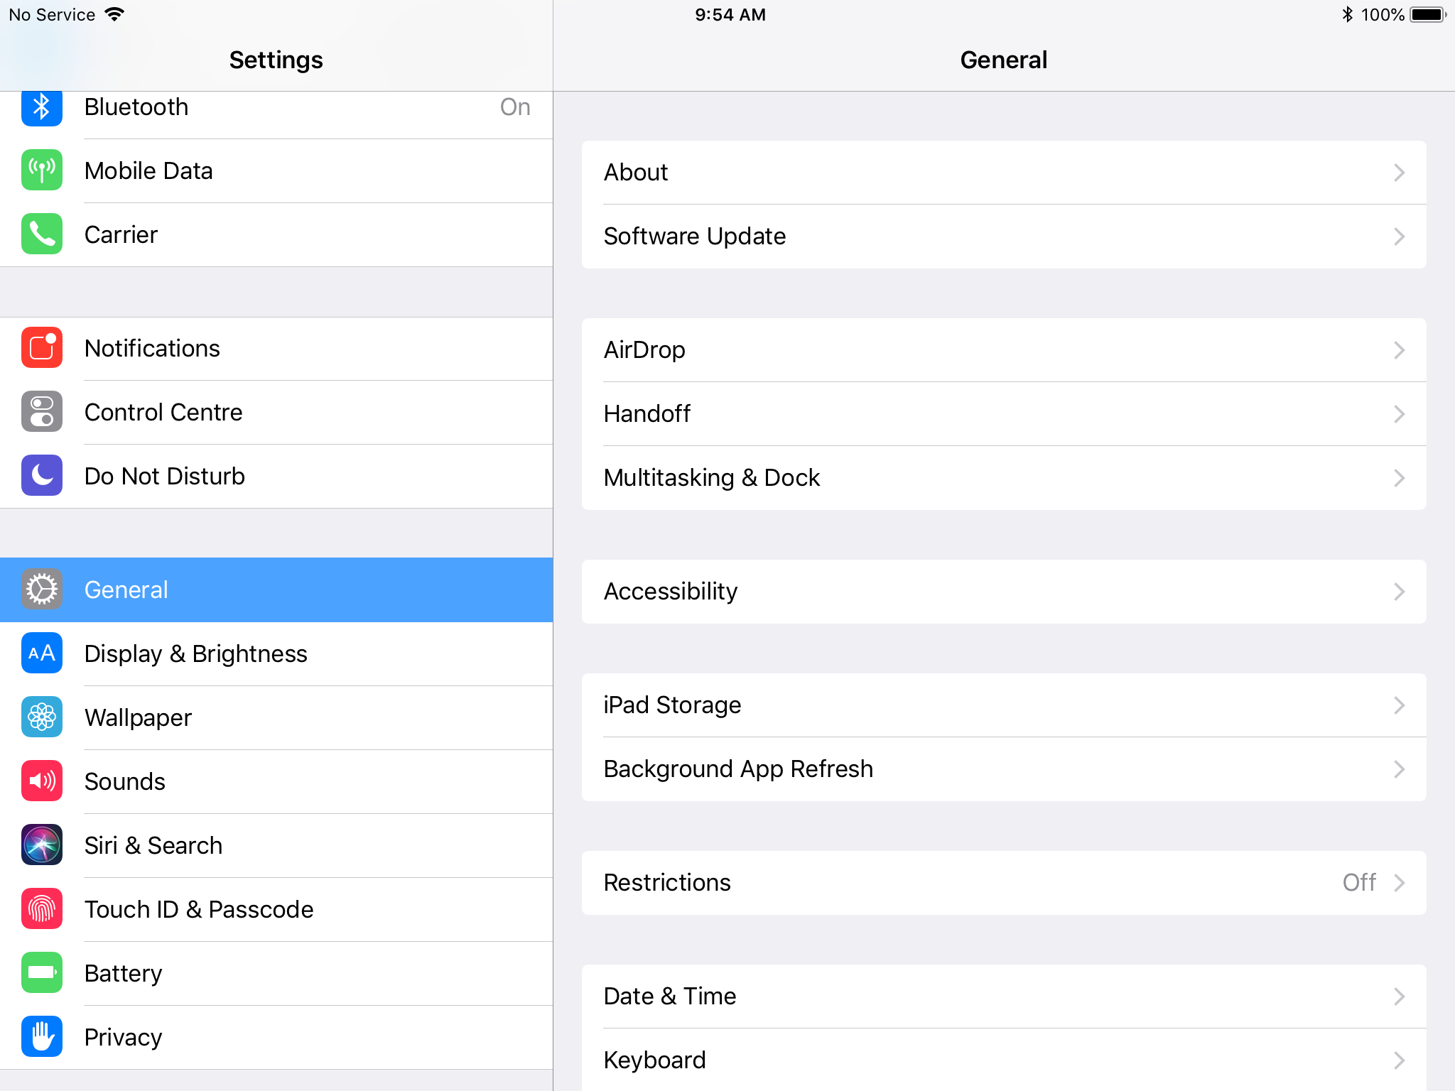Scroll on the left-hand side bar and touch “Touch ID & Passcode” when you see it. You will be prompted to type in your current passcode.
3. Touch “Change Passcode” 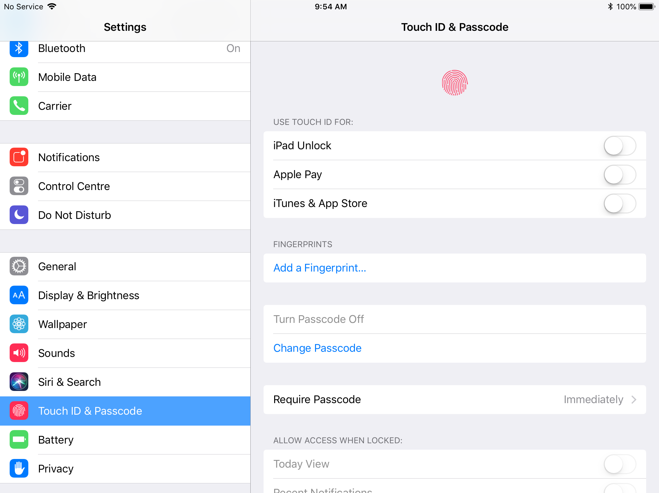
4. 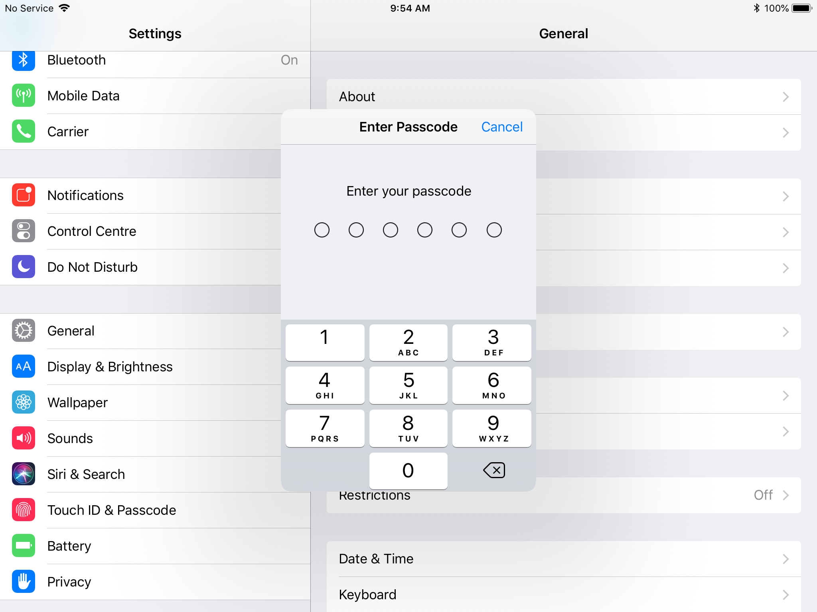The pop up below will appear, type in your current password and then the new password you’d like to set twice. This password has to be at least 6 digits long, it cannot contain ascending, descending or repetitive numbers.
5. If you’d like to set up TouchID you can do this by touching “Add a Fingerprint”



If you forget your iPad passcode, please call the service desk on 02082272013

**Connecting to an external Wi-Fi network**

Your iPad is set up to automatically connect to the LBBD Wi-Fi network, however if you’re working from home, a coffee shop or anywhere else that offers Wi-Fi you’ll need to follow the steps below.

1. Touch on settings application on your home screen
2. 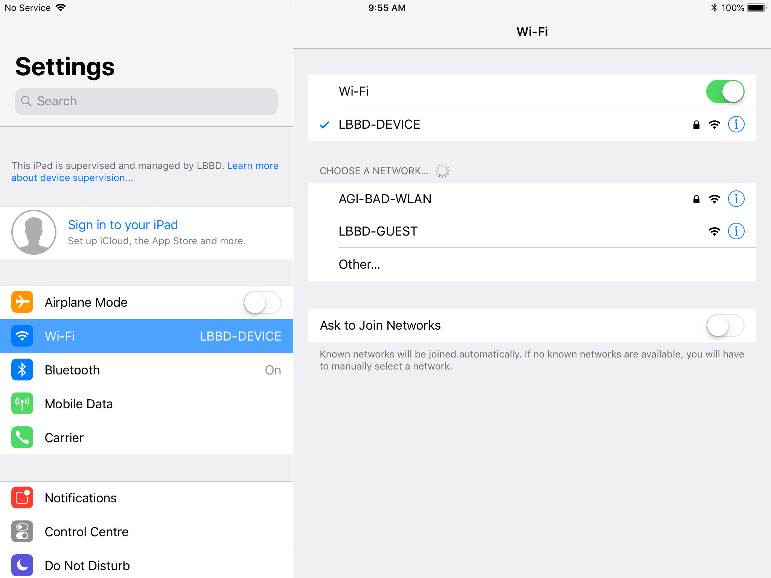On the left side bar please touch Wi-Fi
3. Touch the network you’d like to connect to E.G (AGI-BAD-WLAN)
4. Type in the Wi-Fi password if needed and then touch join.

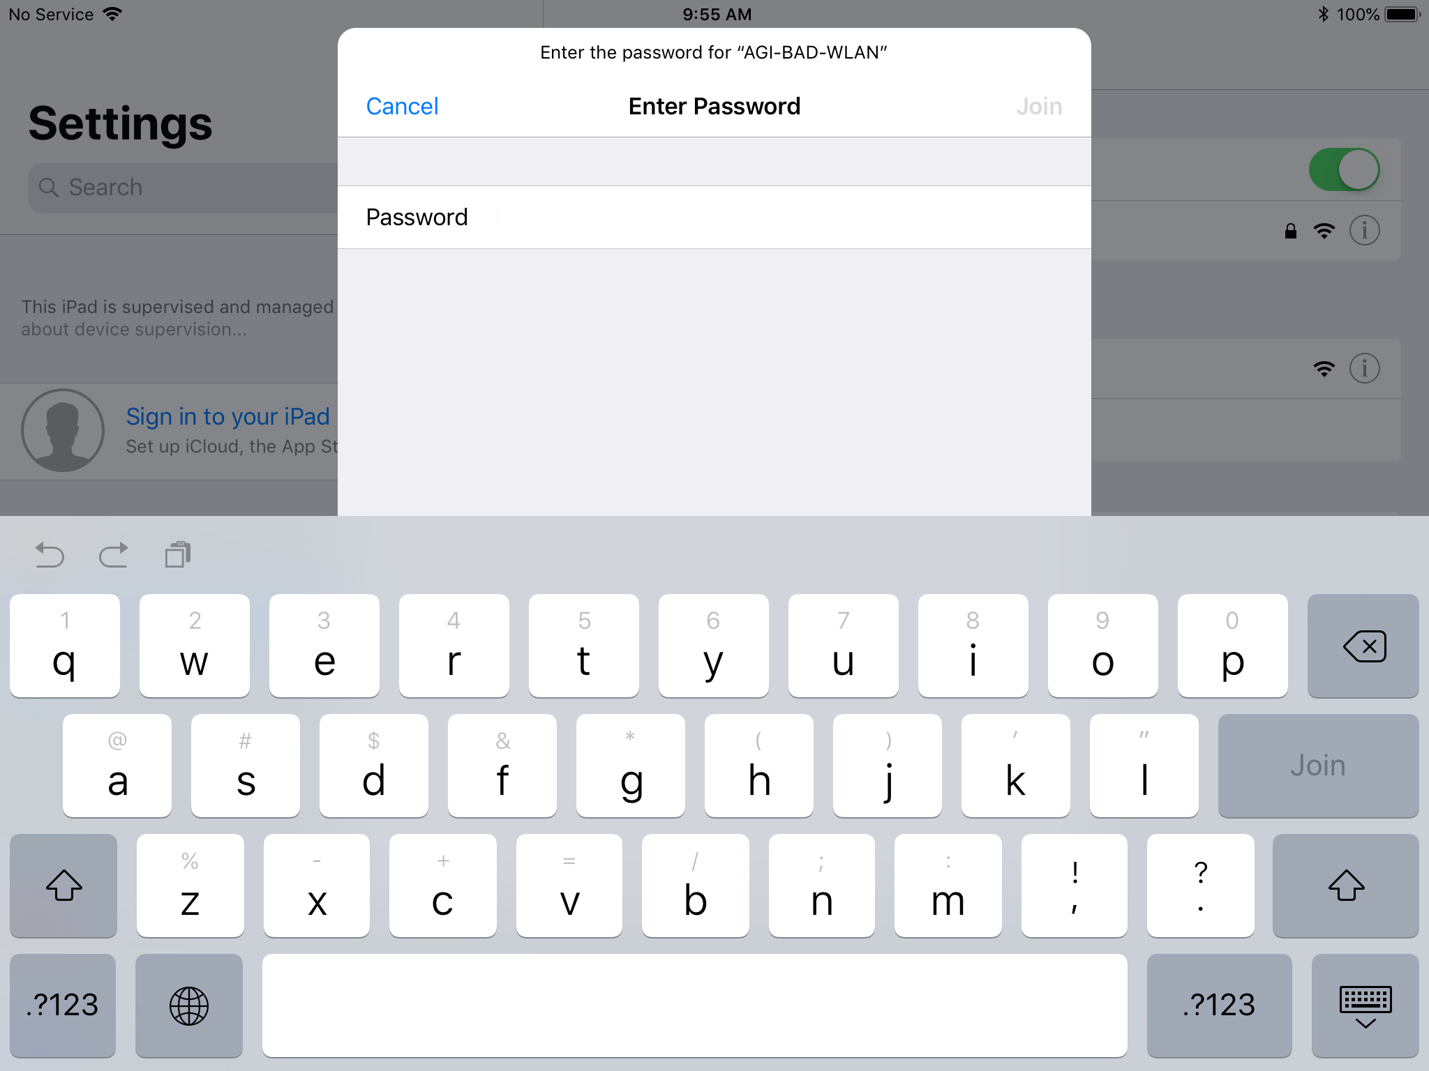

If this is a public Wi-Fi hotspot you may be required to accept terms and conditions or to fill in personal information. Only do this if you trust the premise or organisation.

**Custom Applications**

Your iPad has been loaded with a number of custom applications.

1. Mod.Gov

Mod.gov is an app for automatically downloading, viewing, and annotating meeting papers



1. Members App

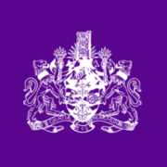The Members App is an online updateable Members Handbook. It provides all the information and links B&D councillors need 'at your fingertips'.

1. MyAccount

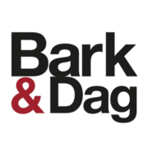MyAccount is the best way to access all of LBBD’s online services. You’ll be able to check council tax and housing benefit bills, report fly tipping and other issues, apply for parking permits and access many other LBBD services.

1. New Case

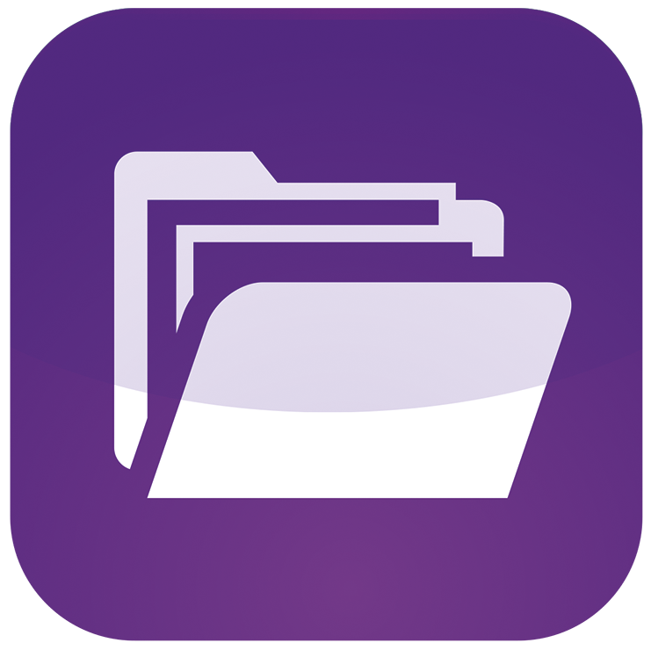New Case is a shortcut to quickly send details of a case to the [members.feedback@lbbd.gov.uk](mailto:members.feedback@lbbd.gov.uk)