**BYOD (Bring Your Own Device)**

LBBD have recently rolled out BYOD for iOS and Android devices. This allows LBBD/Elevate to control only the Microsoft applications on your phone that have LBBD data on them.

Please remember to use your UPN not your email when signing in, this is jbloggs@lbbd.gov.uk instead of your full email.

Please follow the instructions below, this service is optional and is not supported by the Elevate Service Desk. Please only call the Elevate Service desk if you have lost your device and LBBD data needs to be wiped from it.

**iOS**

You can set this up on your iPhone or iPad that runs iOS 10.1 or above

1. 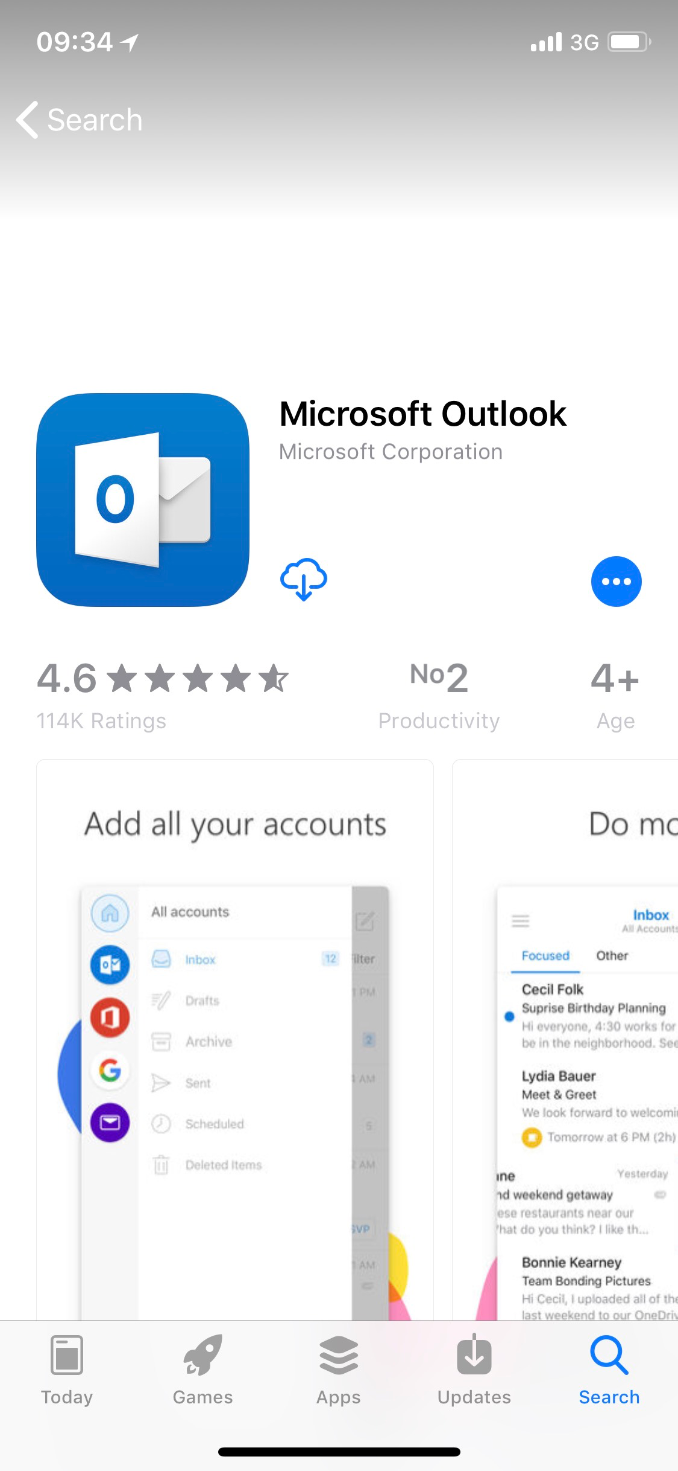Download the Outlook application from the App Store
2. 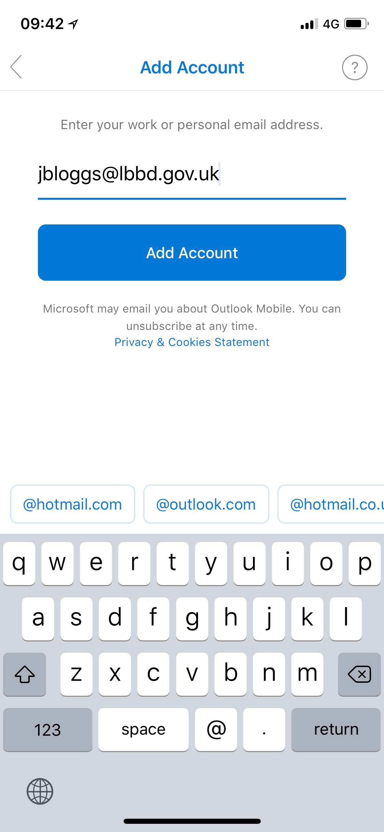Open the application and type in your work user name (UPN). This is in the format jbloggs@lbbd.gov.uk instead of your full email.
3. 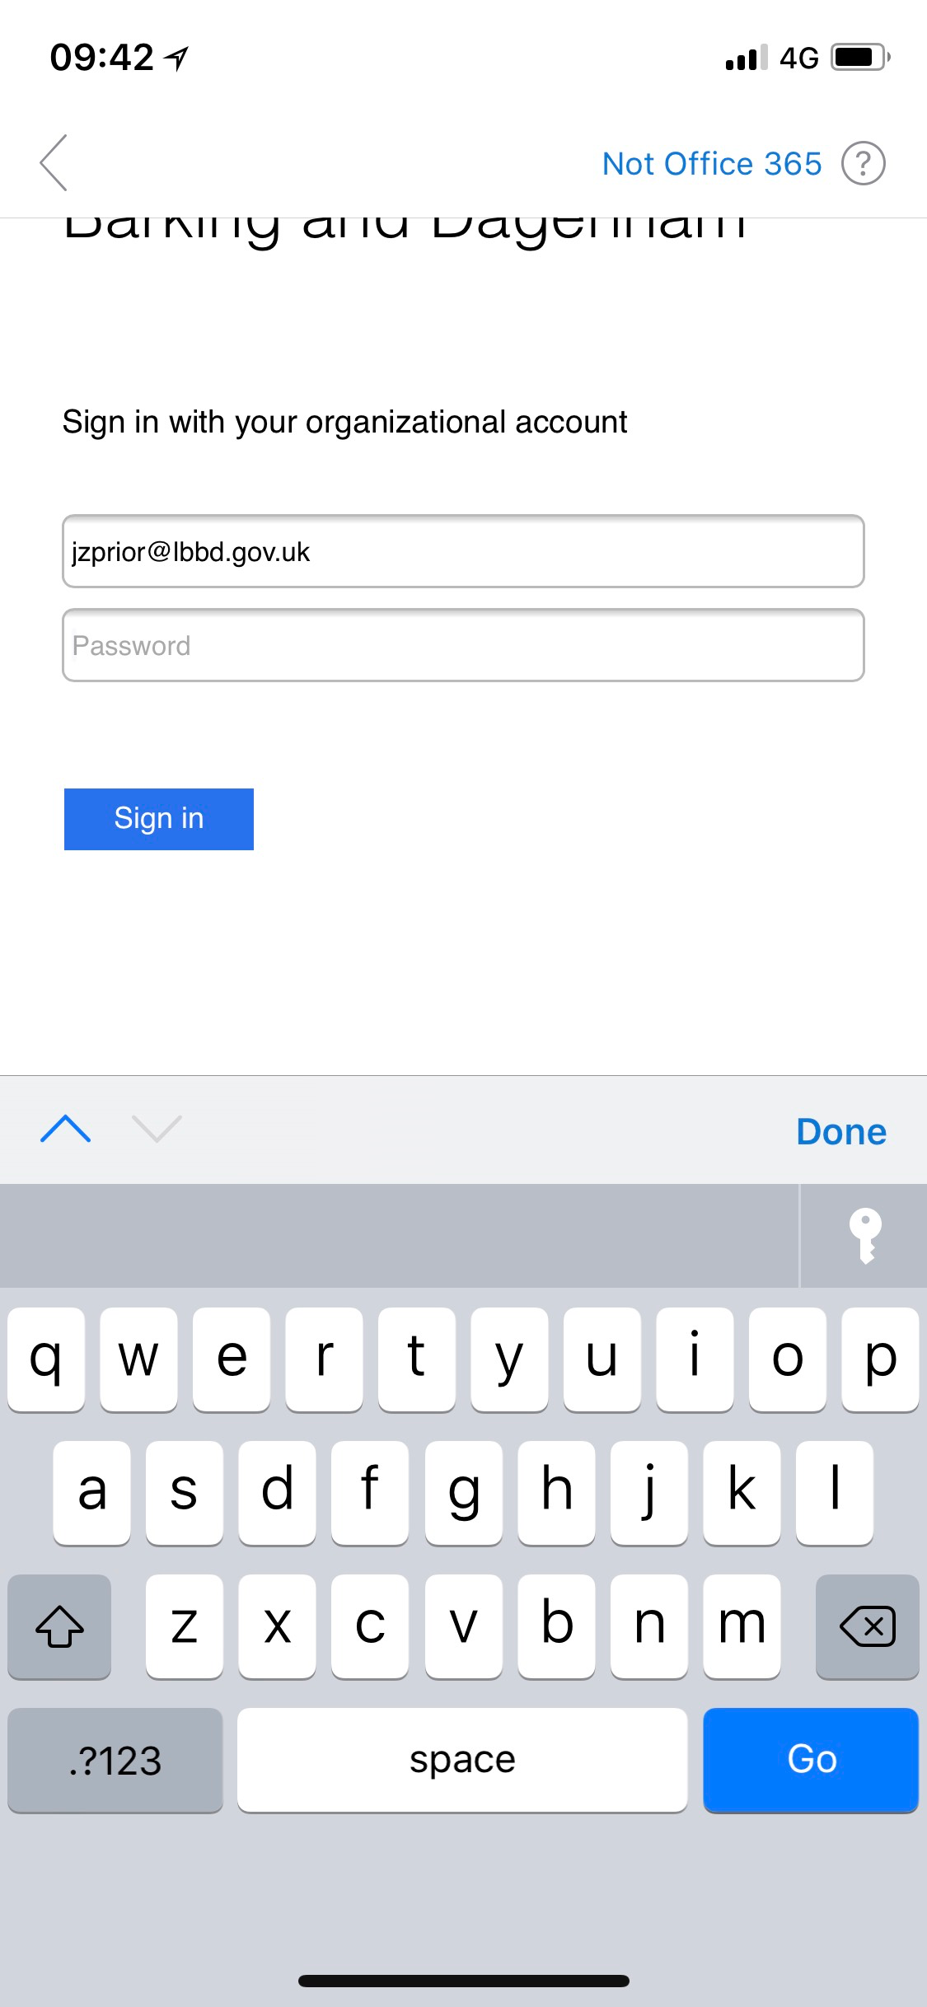Enter your network password and touch sign it.
4. 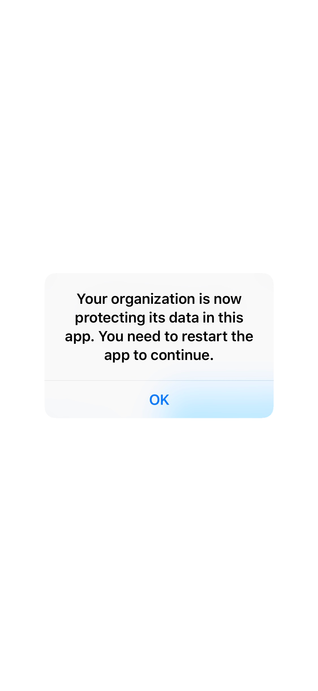Once you have signed in outlook will show you the popup below. Please push “OK” and Outlook will restart.
5. 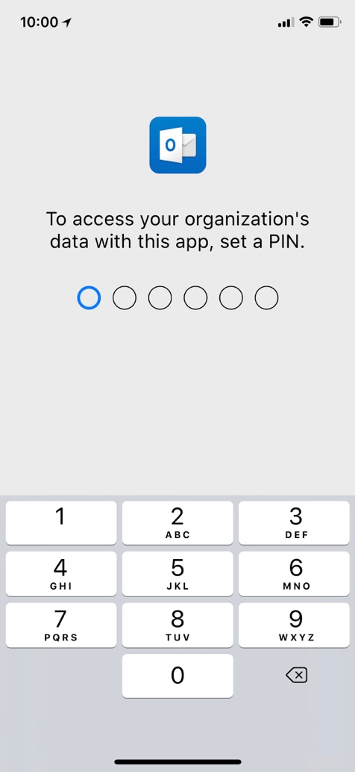Once you open Outlook again it’ll ask you to set a 6-digit pin. This will be used every time you open the app., Once you set the pin, you’ll be able to use your fingerprint or face to unlock instead, depending on your device.

**Android**

You can set this up on your phone or tablet that runs Android 4.4 and above

1. 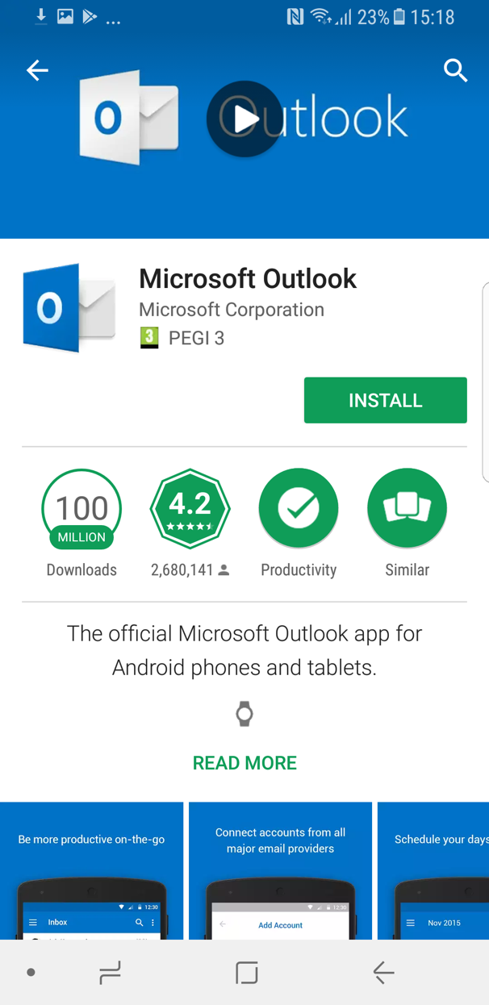Download the Outlook Application from the Play Store
2. Open the application and type in your work user name (UPN). This is in the format **jbloggs@lbbd.gov.uk** instead of your full email. Then touch continue

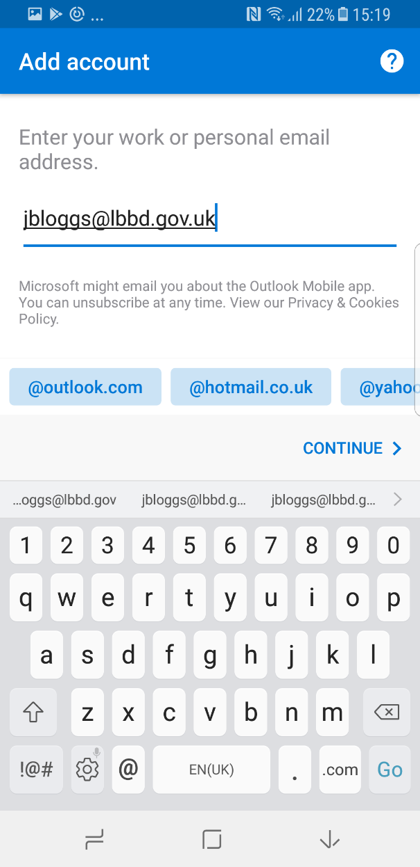

1. 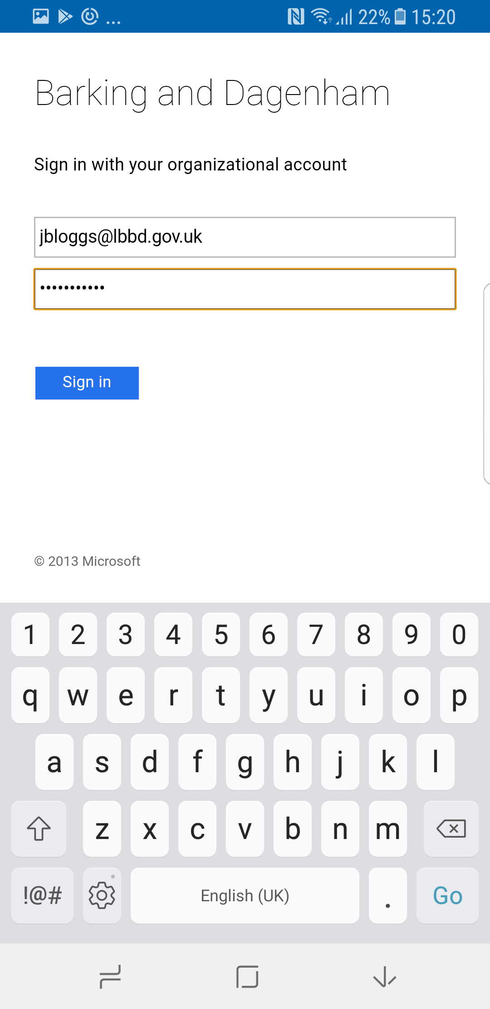 Enter your network password and touch sign it.
2. 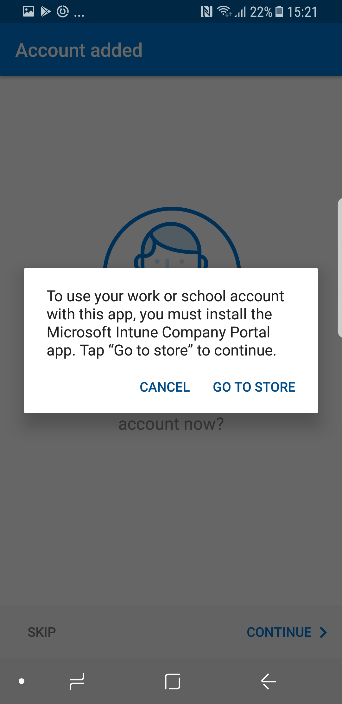The pop up below will appear. Please touch go to store.
3. You’ll be redirected to the play store, please install it. You won’t need to open the application ever, it’s just there to store LBBD information securely in the background. Please refrain from deleting this application.

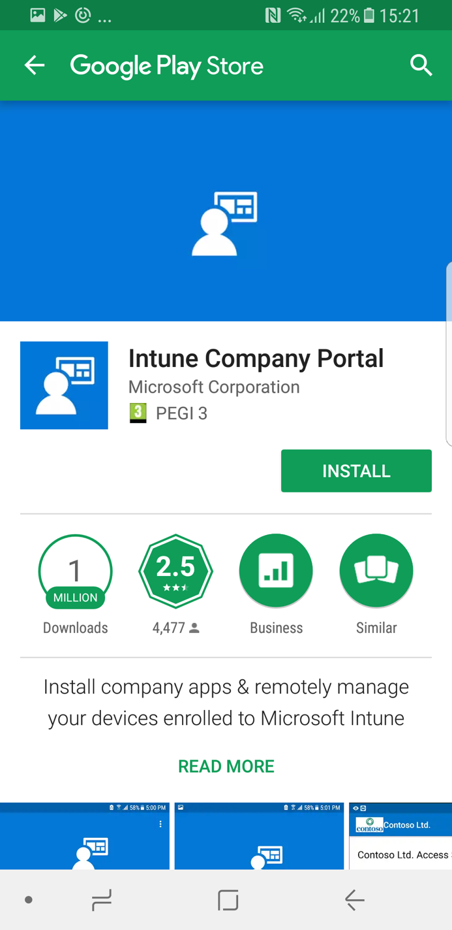

1. Once you open Outlook again, it’ll ask you to set a 6-digit pin. This will be used every time you open the app. Once you set the pin you’ll be able to use your fingerprint on newer Android phones.

